=======Manage VM settings=======

віртуальна машина для ансібла

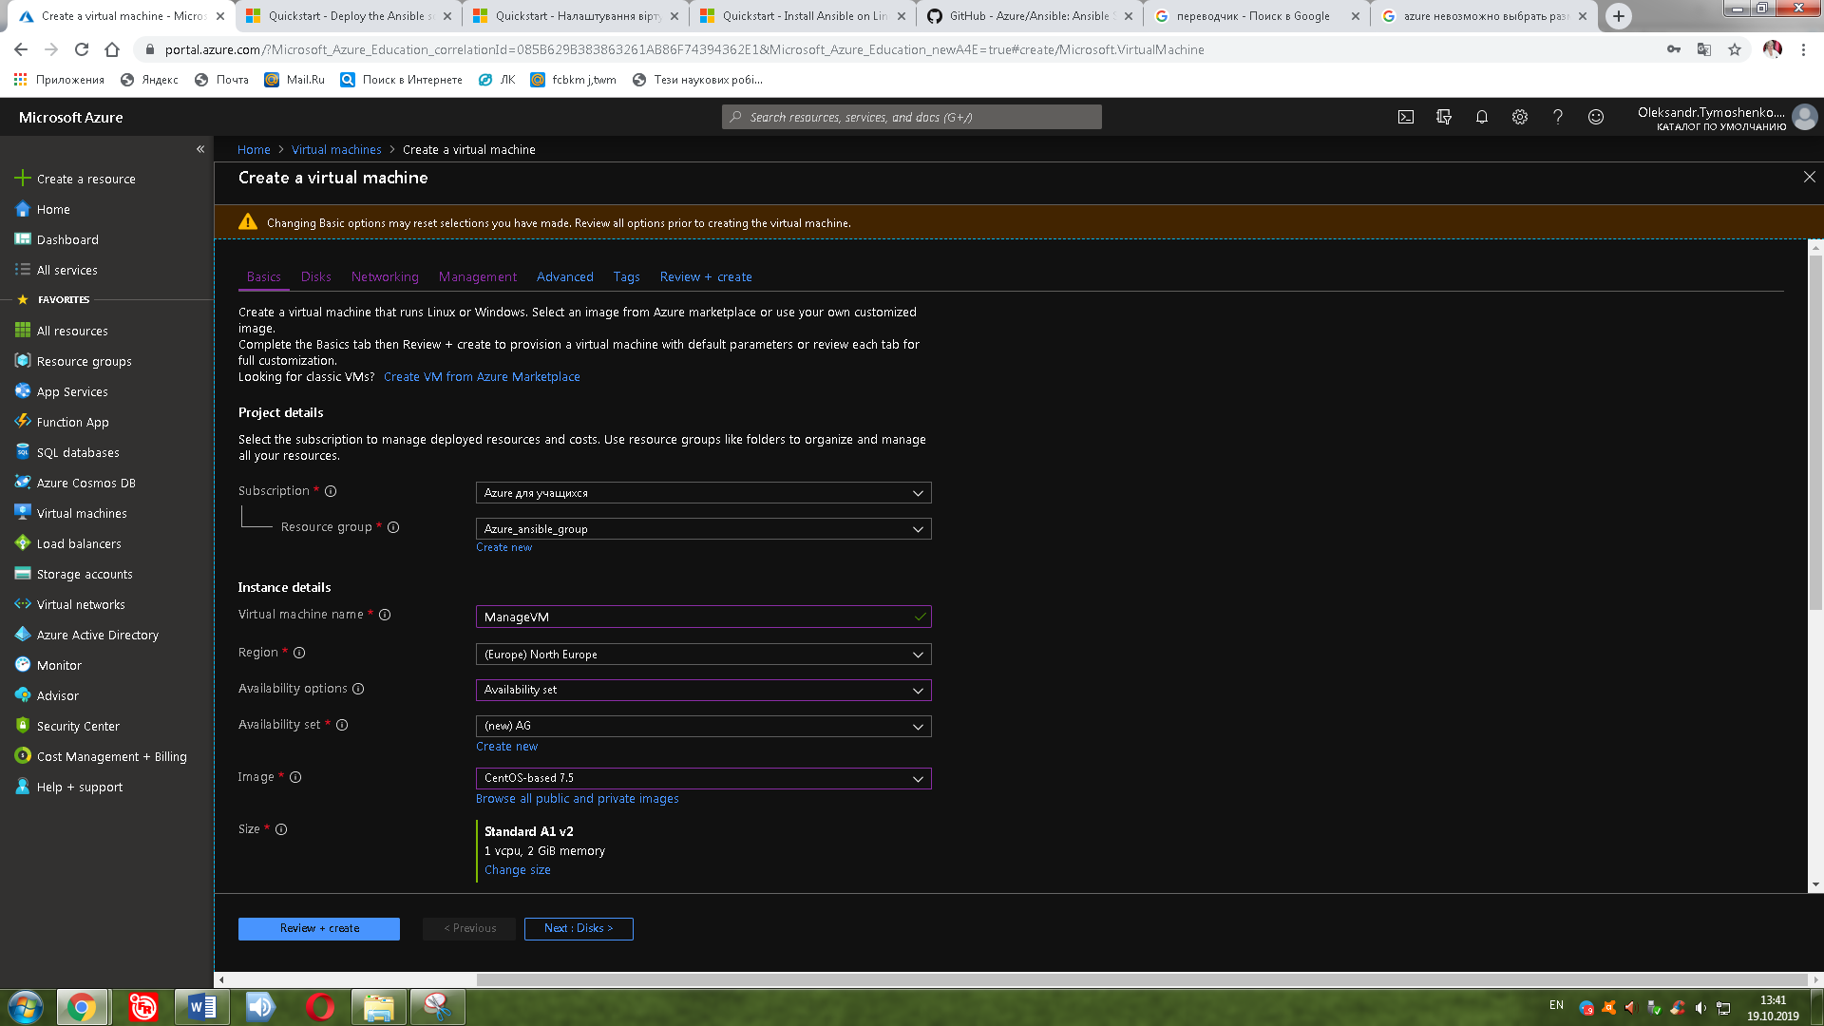

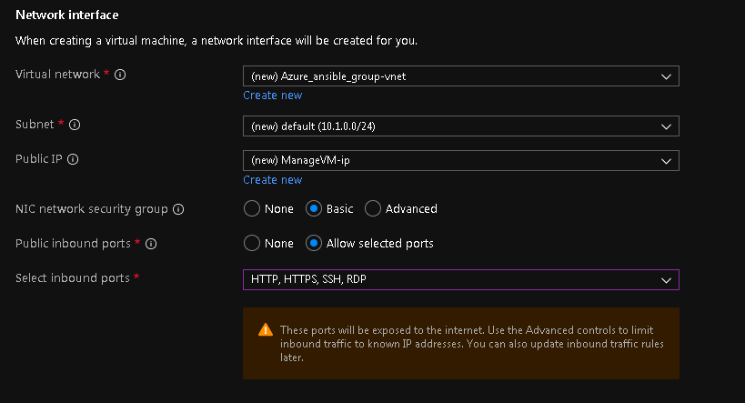

=========Azure shell========

створення головної служби

<https://docs.microsoft.com/en-us/cli/azure/create-an-azure-service-principal-azure-cli?view=azure-cli-latest>

az ad sp create-for-rbac --name ServicePrincipalName

=========VM=========

налаштування ансібла

[https://docs.microsoft.com/en-us/azure/virtual-machines/linux/ansible-install-configure#create-azure-credentials](https://docs.microsoft.com/en-us/azure/virtual-machines/linux/ansible-install-configure" \l "create-azure-credentials)

sudo yum check-update; sudo yum install -y gcc libffi-devel python-devel openssl-devel epel-release

sudo yum install -y python-pip python-wheel

sudo pip install ansible[azure]

mkdir ~/.azure

sudo nano ~/.azure/credentials

<https://www.azuredevopslabs.com/labs/vstsextend/ansible/>

Create res group (test settings)

ssh-keygen -t rsa

touch rg.yml

sudo nano rg.yml

---

- hosts: localhost

connection: local

tasks:

- name: Create resource group

azure_rm_resourcegroup:

name: ansible-rg

location: westeurope

register: rg

- debug:

var: rg

ansible-playbook rg.yml